Game Design Document
Viola
GAT 315 – Spring 2018
{PICTURE HERE}
Version: 1.0.0

Overview
High Concept

Viola is a 2D side scrolling platformer in which the player journeys with their two sentient fairy weapons, Blu and Rosso, in order to defeat Giallo, who has captured the fairy kingdom, and save the forest.

Viola is intended for gamers who enjoy adventuring, quick smooth character movement, and cinematic camera work. Rated E on the ESRB scale.

Theme / Setting Brief

Viola takes place is a saturated pixel art world going through nature settings. Taking inspiration from Mika and Ori & The Blind Forest, the world will contain lots of nature elements and cinematic camera movements. Players should feel adventurous and excited, going through a captivating adventure through a peaceful world corrupted by monsters.

{PICTURE HERE}

Core Gameplay Mechanics/Features Brief

- Movement
- Wall Jumping
- Dash
- Auto-Aiming Weapons
- Cinematic Camera Work

Project Scope

Primary development will take place over the course of the Spring semester at DigiPen (2018). Game length will be around 15-20 minutes depending on level lengths in between narrative beats. Development may continue for another semester depending on project outcome.
Targeted Platforms

- Windows

Targeted Controls

- Xbox 360 Controller (Primary)
- Keyboard (Secondary)

Outside Resources

- Paint.NET
- Unity 2017.3
- Visual Studio 2015
- Audacity
- Mika art assets (DigiPen Game with permission from creator Tristan Begin)

{PICTURE}
Design Influences
Mika (2016)

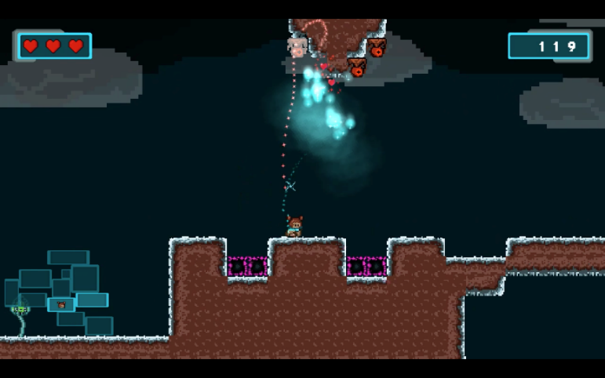
Mika is a large influence for the games visual style. Mika’s tile sheets and art assets will be used for the majority of Viola’s art. It is a DigiPen game so the assets are owned by DigiPen and “permission” was received from the creator of the assets Tristan Begin. Its use of 2D visual design will be replicated in Viola, allowing the different levels to feel unique and visually interesting.
In addition to Mika’s visual style, Viola takes inspiration from the mechanics. Mika has wall jumping, dashing, and weapons that are similar to the idea that Viola has. Viola uses this game as a basis for how its main mechanics could function and how to use that to create interesting levels and encounters.

Ori & the Blind Forest (2015)

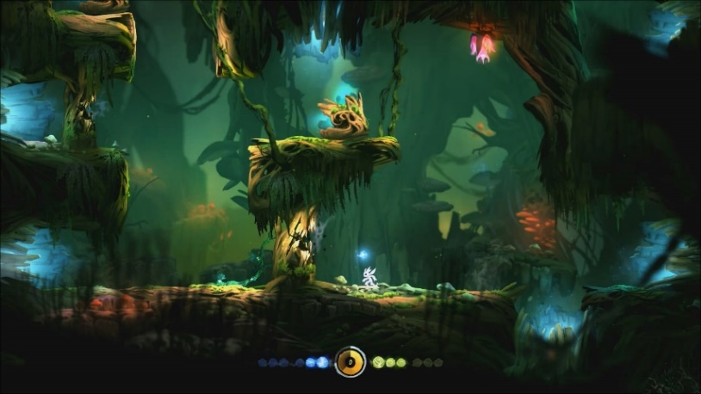
Ori & the Blind Forest acts as the main inspiration for the story-telling and weapon mechanic that will appear in Viola. Ori features a nature and coexistent theme that Viola’s main plot is exploring. Its sense of adventure and progression, along with its story telling techniques with minimal text but meaningful ones is what Viola will use to portray its narrative.
Along with the narrative elements, Viola uses Ori as an example of using camera work to create evocative moments within the gameplay. The camera work in Ori is cinematic and beautiful. All while working with the gameplay to create a unique experience. Cinematic cameras allow the narrative and gameplay to thrive and is a major focus of Viola.
Ori’s gameplay and combat style is the main inspiration for Viola’s Rosso and Blu. Ori’s combat is less focused on the actual fighting and more on surviving and movement. Ori’s weapons are auto-aimed and the player has to more focus on dodging the enemies and moving around them instead of focusing on aiming. It capitalizes on the smooth camera movement and visuals and is something Viola is out to achieve.
Hollow Knight (2017)

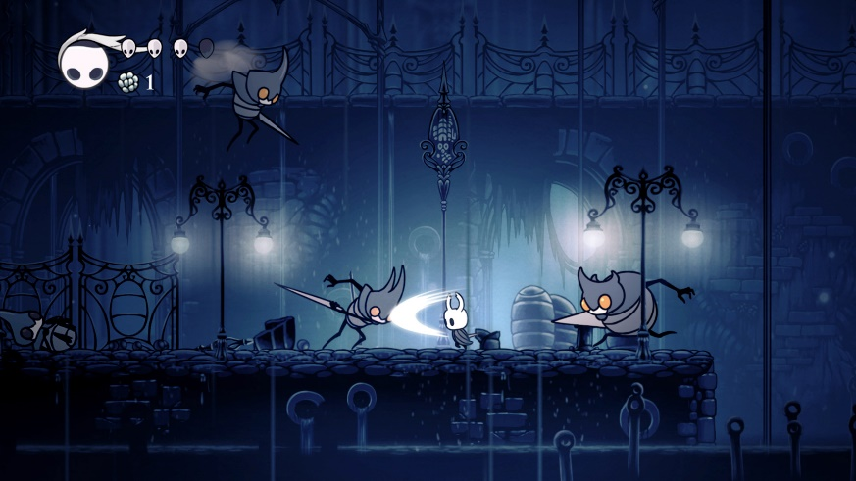
Hollow Knight offers a lot of inspiration for the general design of the games UX. The UX in Hollow Knight offers clear and meaningful communication of what is happening in the game. When a player dies, gets hit, is low on health, or attacking. Hollow Knight never misses to give a lot of clear feedback to the player. Viola will be using Hollow Knight as inspiration for its feedback.
Along with the UX, the UI in Hollow Knight is also important to look at. Its in-game HUD and menus are clear and communicate a lot to the player. They fit the theme perfectly and are visually appealing while also not getting in the way of gameplay. This style of UI can be looked at for designing Viola’s UI.

Celeste (2018)

Celeste is a bit different than the other games on this list but offers something that is unique to it: its simplicity in mechanics but depth in design. The game only has two real mechanics but uses the level and components in the world to bring depth to those mechanics and make the player think outside the box and use their knowledge in different and unexpected ways. This depth in the levels and movement of the player is something that Viola will use in its levels to make for an interesting world for the player to navigate through.

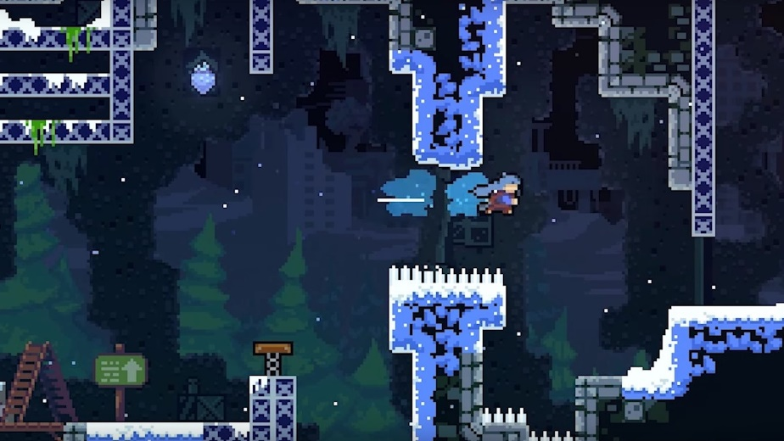
Mechanics Detailed

Movement

The movement in Viola has to be smooth. The main focus of the gameplay is the player’s movement around the level and navigating around enemies. For this the player needs to smoothly flow through the level in all their movements. The player controller will allow the player to move around and jump. Holding the jump allows them to gain more height than if they tap it. It should feel a bit flowy when it comes to just moving around but allow the player to switch direction and transition to a jump fast.

Wall Jumping

A majority of the vertical movement that takes place in the game will be achieved through wall jumping. Players will be able to get into a wall jump from the ground and air by moving into the wall and either pressing or holding the jump button. The jump will follow a parabolic spline arc. If the player holds their direction during the wall jump they will follow the arc. This will allow for reliable, smooth, and tuned wall jumping. It makes the wall jumping feel smoother and allows the arc to be tweaked to follow the rhythm and tempo of the gameplay. If the player decides to switch directions during the arc they will leave off with the same velocity but will no longer continue to follow the arc. While on the wall the player will be sliding slowing down their downwards movement slightly.

Dashing

Dashing should be quick and effective. It will largely be used for dodging enemies and quick movement through gaps in the level. When dashing the player’s velocity will be set so there is not charging up or slow delays. It will be precise and timed so that is it reliable. If the player hits something on the way the dash will end. This allows for smoother transitions between dashing into wall jumping and smoother movement in general. During the dash the player’s sprite will shadow behind them, causing the effect feel more powerful.

Weapons

The combat is secondary to the movement in Viola. For this I made the decision for the weapons to be auto-aimed in order to shift the player’s focus onto navigating the level and avoiding enemy attacks. The weapons (Rosso and Blue) follow a rhythm to their cooldown and returning. Their travel times are around 0.25 seconds. The player has to wait for the weapon to attack and return in order to attack again. This creates a steady tempo of attacking. Additionally once the player gets both Blu and Rosso the rhythm will be the same but with a faster tempo, creating a nice and smooth combat style.
A major focus of Blu and Rosso is to make them feel different although in reality they are the exact same script. In order to do this their movement around the player, level, and attack need to be independent but in sync. When standing still they will float around the player’s head in a flipped pattern to each other. When following the player they follow a helix around each other so they are independently moving on the screen and not overlapping. Finally, when attacking they will follow an alternating parabolic arc toward the enemy and come straight back.

Health/Checkpoints

Health is going to work the same way it does in Ori. Around the level there will be a plant that the player can attack and it releases health for the player to collect and restore their life points. The player will have 5 health points. If the player loses all their life points they will respawn at the last checkpoint with all the enemies being reset. Checkpoints are marked with orbs that the player hits to activate.

Enemies

Roller – This enemy charges up and rolls toward the players, quickly changing directions. The player has to cause it to run into a wall revealing its back side and allow it to be taken out.

Flying Chargers – These enemies fly around in the air. They lock onto the player and quickly sweep toward them.

Chargers – These enemies are large and bulky. They are armored in front but can be hit from behind. They lock onto the player and rush toward them, knocking them back.

Level Interactions

Bounce Pads – These pads launch the player quickly in the direction they are facing if the player jumps on them.

Redirects – These floating items allow the player to aim their dash in any direction. If the player holds down dash while close to them it will go in slow motion and the player can use their thumb stick to orient their dash direction.

Hazards – These are general hazards along the floor and walls that the player will have to avoid or take damage.
Aesthetics Detailed

Catharsis (Primary)

The main focus of Viola is to bring the player through the world and adventure that the main character and his two fairies are in. The player should be compelled to keep playing through their objectives and the world they are in. In order to catch the player’s interest and make them feel emotions I will be using cinematic camera work, as well as putting a focus on conveying a plot and objectives.

Fellowship (Secondary)

Fellowship comes in a close second to Catharsis and is hit on by the companions Blu and Rosso. The main narrative and dialogue set up these characters and their relationship in the world. The main thing that the characters hit on is that they are going through this adventure with you, acting as your weapons to free their families. Having these fairies with you on your journey will hit on the fellowship engagement, especially when the narrative turns to rip them away from the player.

Challenge (Tertiary)

The gameplay in Viola take care of the challenge engagement type. The main way of getting challenge is going to be through the movements the player will have to do and dodging enemies. Aiming is not needed in this game so the movement needs to be responsive and reliable in order for the game to really push and challenge the player. Whether it be platforming or fighting enemies, Viola will challenge the player and the smooth movement of the game will make it enjoyable. Hopefully.

{PICTURE}

Level/Environment Structure Detailed

World and Setting

Viola takes place within a forest realm where fairies coexist with “humanity” protected by the Portal guarding them from the outside. It is peaceful and calm within the realm while everything outside is mostly dead and corrupt, filled with aggressive creatures. The breaking of the portal mixes these two worlds and the player has to restore peace back to nature.

Viola will feature pixel art, focusing on modular pieces, camera work, and colors to bring the world to life.

Viola will reveal its backstory through a short intro with minimal text panning through some art. The main narrative and plot will be communicated through dialogue and goals of the player.

{PICTURE}

Level Design

Viola’s level design will be focused on movement and cinematic moments. The camera work in hand with the smooth movement of the player will be used to create an evocative setting and pull the player through the level. Viola follows a main story and the player will adventure through the levels as they do through the narrative. No open world or backtracking, just through to each section of the game as the narrative is revealed. There are enemies around the levels but the design of the levels will mostly focus on the player’s ability to maneuver and dodge the enemy attacks within the space. Platforming and movement is the main focus of the gameplay and will be reflected in the level layout.

Camera Modes

Viola’s camera will be manipulated using triggers throughout the level in order to fill the screen at the appropriate size and focus on the correct things. It by default follows the player while keeping into account the player’s speed in order to keep the subject in focus. The focus of this camera is to be smooth and have nice transitions between areas and dialogue moments.

User Interfaces Detailed

Controls

Primary focus of controls is Gamepad but it will also easily support keyboard.
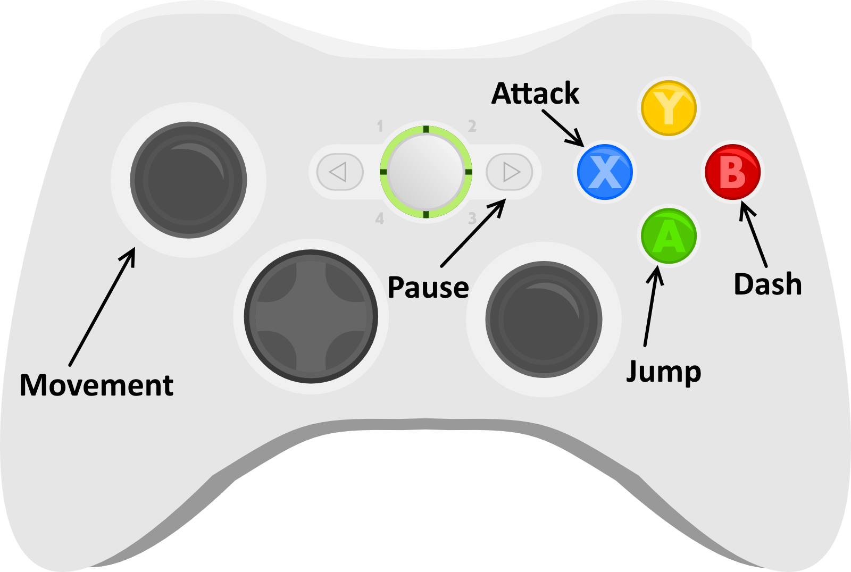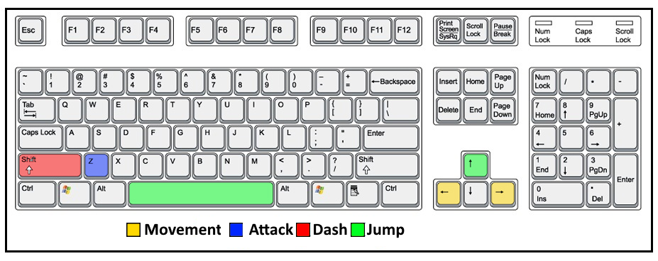
Secondary:
Primary:
Primary:

Menus

For more information and wire framing check UI_Design.pptx.
Main Menu
- Simplistic style with text for buttons
- Viola fairy on buttons and if two markers are needed then Viola splits into Blu and Rosso to mark both
- God rays for gradient moving slowly with light particles around
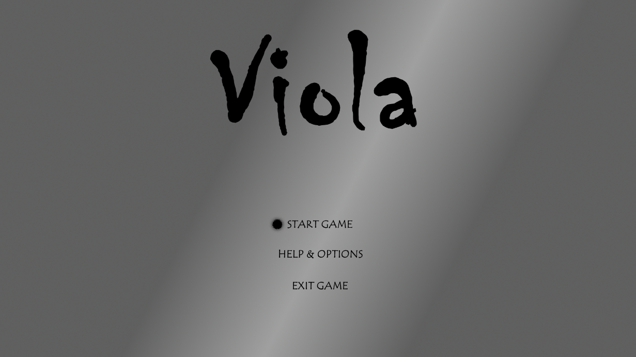
MENU SCREEN
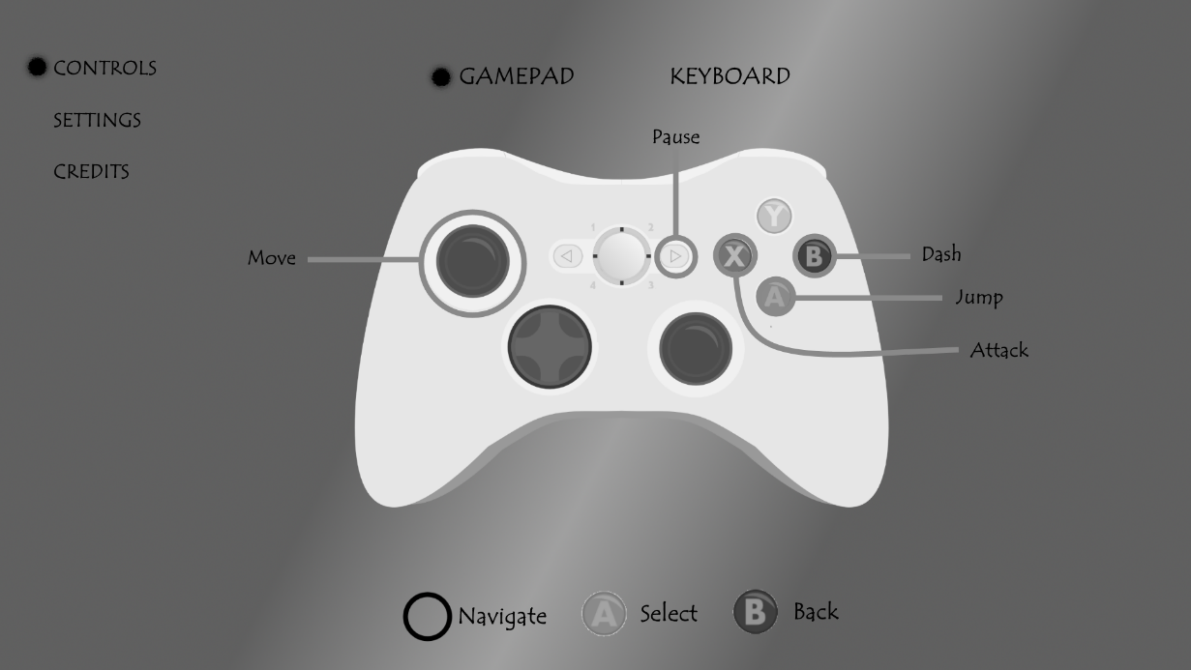
OPTIONS SCREEN

Pause Menu
- Same menus as options on main menu
- Options to quit to main menu and exit game with confirmation screens
- Black overlay of game to separate more clearly
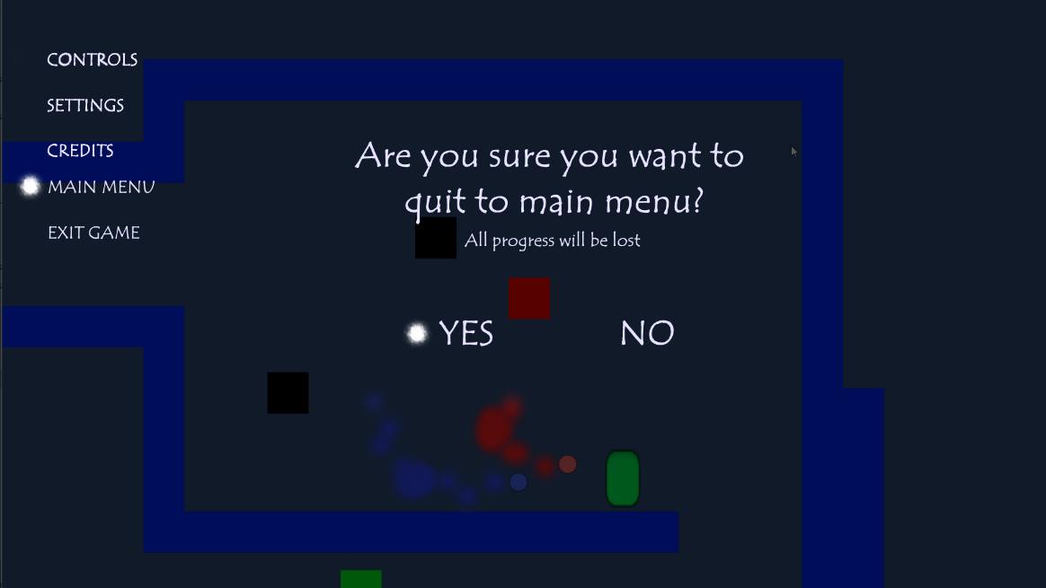
PAUSE SCREEN

HUD

- Top left reserved for health. Health breaks apart when lost, vines for nature decoration
- Talk able NPC will have a small box on top of them, when you get close enough the “!” Changes to the button to interact
- Dialogue spot is on bottom of screen. Must make sure to keep framing open for places with dialogue.
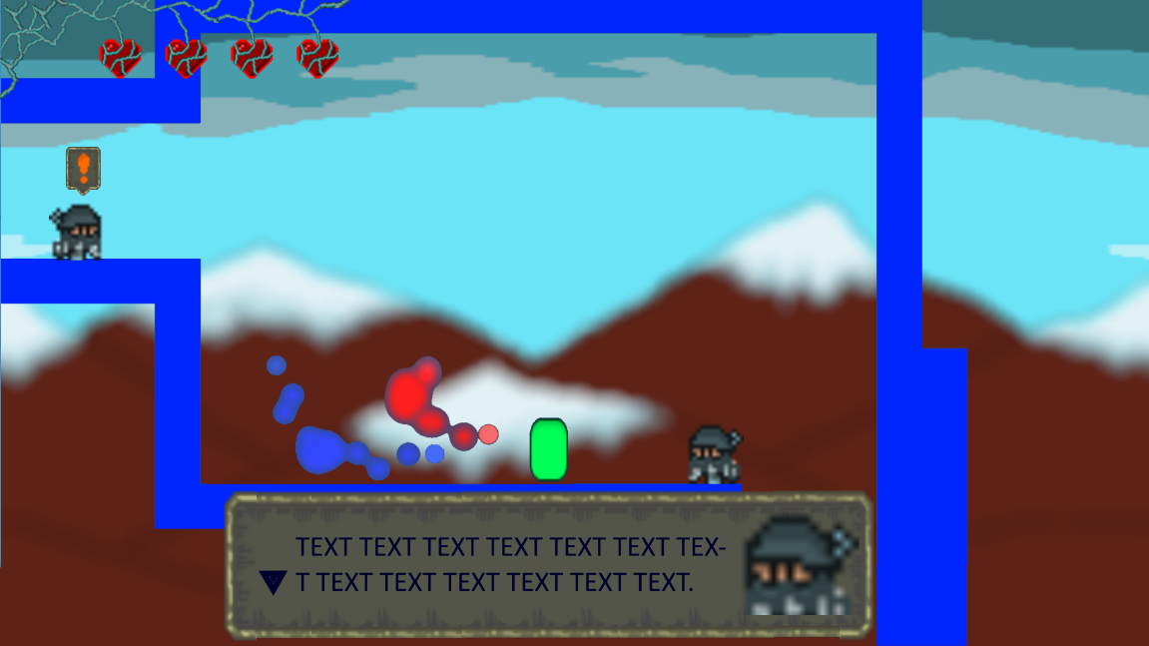
GAME HUD
Art Style Detailed

Art Style

The art style is largely based on a mix between Mika and Ori. For the foreground where the detail really matters it will be using all of Mika’s pixel art. Different beats in the story will use different tile sheets (thankfully I already have a lot of different types) to make the areas feel more unique. The background will be less pixel and more fluid brush strokes in order to make a clear separate in layers and also keep the foreground more important for its detail and saturation is higher. The setting is fully nature with the exception of the beginning of the game.
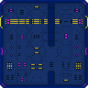

Animations

Animations will be through sprite sheets. The main characters will be a re-design of Mika’s character since all the animations already exist. Other than the main character there needs to be animations for the main boss and the different enemies in the game. The enemies will have 2-3 states each but can be quickly done and revisited later with time. Since the bulk of art has already been provided there should be room for getting in the necessary animations later in the project. The majority of time spent on animations will be for FX whether it be player getting hit, hitting enemies, or other VFX.
Animation List:
- Character Run/Idle/Fall/Wall-Slide
- Giallo Run/Fall/Idle
- Flying Chargers: Idle/Enraged/Charge/Fly
- Chargers: Idle/Enraged/Charge/Walk
- Weapon Hit VFX
- Player Hit VFX

Audio Detailed

Music

The music should be rather light and peaceful. It should calm the player down and not be too exciting. The game should be hitting on this nature theme and in order to do that the music should follow that tone. Soft tones and peaceful rhythms will help convey the desired mood and tone of the game. I will either find music on the DigiPen recourses or find music from Mika and see if there is anything there that can be used to portray this peaceful tone.
Music List:
- Main Menu Music
- Pause Menu Music
- General Level Music
- Giallo Fight Music

Sound Effects

I hate to break the immersion with the art and visual look but the sound effects will have to be through my voice making the noises. I can record my own voice and then go into audacity to alter it. This will allow the production of very quick and plentiful sound effects. SFX is an important part to UX and the faster it is produced the more feedback can be put into the game.
SFX List:
- Player Hit/Jump/Wall Jump/Land/Run/Dash
- Weapon Hit/Attack
- Blue voice/Rosso voice/Giallo voice/Kid voice (gibberish)
- Charger: Enraged/Charging/Hit
- Flying Charger: Enraged/Charging/Hit
- Roller: Enraged/Hit/Traveling
- UI: Button Entered/Button Clicked/ Menu left/ Pause opened/
- Portal explosion
- Bounce pad
- Redirect

Main Story

Preface

Viola will follow the three act structure removing the fall for scoping restrictions. All the narrative will be communicated through visual in game cinematics and text dialogue between the characters. It will have minimal use of dialogue and giving just enough information to the player again due to scope reasoning.

Characters
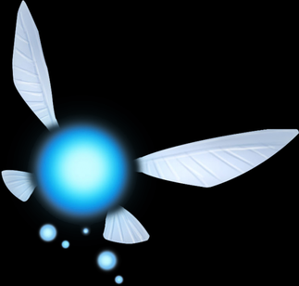
Blu
Species: Seelie Fairy
Role: Support
Backstory: Blu was born and grew up within the protected realm. Blu has never left outside the portals protection or has had a human partner. Blu helps the humans in any way it can, growing up by their side and appreciating their relationship with the fairies as partners in nature. Blu has not taken on any partner due to wanting to aid every being in the realm. Also no human can stand Blu’s non-stop talking and positive attitude.
Personality: Bubbly, Kind and selfless. Optimistic attitude in life and will not hesitate to ask for assistance or to assist.
Goals: Wants to warn the humans of any danger going on. Once everything goes wrong Blu wants to return the peace in order to bring the world back to a neutral and peaceful state.
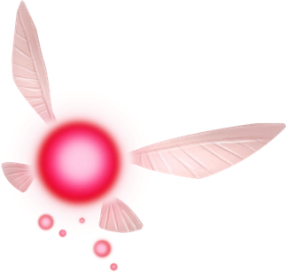
Rosso
Species: Unseelie Fairy
Role: Support
Backstory: Rosso, originally from the realm, took on a partner (Giallo) early once seeing Giallo’s power and strength. Rosso spent the majority of his time outside the realm seeing the different sides of nature and humans. Rosso originally had no companions or friends before Giallo took him under his wing.
Personality: Pessimistic, Rude and selfish most of the time. Only shows respect for beings of great power or skill. Never asks for help.
Goals: Wants to get revenge on Giallo for his betrayal and disrespect. Joins player just to defeat Giallo for trying to take their fairy power.

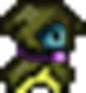
Giallo
Species: Human
Role: Antagonist
Backstory: Giallo was originally outside of the realm. At a young age he left his home town to travel the world in search for meaning. On his travels he met Rosso and took him as his partner. Giallo’s disgust for weak beings manifested as a child, when his parents left him due to the challenge of raising a child.
Personality: Shady, selfish and powerful. Giallo looks out only or himself. He has no concept of good or fairness, only looking for power in any shape or form. Laughs at those weaker than him.
Goals: Giallo’s primary goal is to destroy the portal and bring the peaceful realm into the real world. He is disgusted by the co-existent dream that the village and fairies live in. He wants to bring the realm into reality instead of the peaceful dream it lives in. In order for the new world to co-exist, Giallo must give the fairies to the creatures from the outside. So there can be actual co-existence between the realm and the rest of the world, at the fairy’s expense.

Relationships

The player lived and grew up in the village. This village lives peacefully and coexists with the fairies of the world (both Unseelie and Seelie). Giallo is a traveler who passes through the village a lot and has a distaste for how it is disconnected from the world. Rosso is Giallo’s fairy partner. Every human has their own fairy partner they get. Rosso was originally from the village and so is Blu but Rosso left with Giallo and Blu has always stayed inside the protected area.

Act One - Intro

Short intro going through forest and it’s pretty dark. It shows the edge of the main portal’s protection where enemies are trying to get in. It shows the portal radiating. The text that shows in this part talks about the realm’s peacefulness and how it protects the forest from the outside world. The real world. Player starts in a village. It is the player’s turn to get their fairy companion which is a thing in the village as they coexist with the fairies. Walking a kid frantically is running and when you talk to him he says he lost his fairy and can’t find them anywhere. You bump into Giallo here, as he pushed you down. He comments on your weakness and is rather rude. He is accompanied with Rosso who also says something rude. You then continue to the forest to get your own fairy buddy.

Act One - Reveal

In the forest you find Blu who is trapped. Blu asks you to help them out and comments saying it was probably their own fault and something optimistic about you showing up when you did. After helping Blu out Blu says they should head back to the village and tell them that some other fairies probably also accidently fell into some traps. On the way the portal in the back explodes and Blu is terrified and runs off to the village ahead of you.

Act One - Break

You get back to the village and it is destroyed. Giallo is there with his army of outside enemies. Fairies are there asking what is going on and are frantic when Giallo starts to capture all of them. He regrettably goes to place Rosso in his control but Rosso gets away. He then tells his army to go search for all the fairies and leaves. Blu says some stuff about how bad this is and how he’s never been outside the realm. You fight with Blu to go to the portal and fix it.

Act Two - Ride

You fight and jump around going through the world. Later is where you find Rosso who is surrounded. You take the enemies out and Rosso says something like he could’ve handled it. Blu and Rosso converse about what’s going on and Rosso reveals his relationship with Giallo. Rosso agrees to accompany you because of your skill in battle and says he wants to get revenge on Giallo for his betrayal toward him and no one else.

Act Two - Turn

You get to the portal and find Giallo there with his army. Rosso and Giallo converse a bit and you fight Giallo. You beat him but he goes into a new phase with his captured fairy power that you can’t break. He captures your fairies and launches you away, saying he needs the fairies so you and the rest of the village can live in the new world.

Act Two - Death

You are now without your companions. You have to rely on your movement alone and navigate around weak. You get to where Giallo is keeping the fairies and find Blu and Rosso there. You break open their cage and are with them once again.
Act Three - Plan

Now together, you continue back to the portal. You get to the portal and Rosso and Blu fix it being spinning into it causing them to combine into Viola, fixing the portal. Viola is both the fairies combined and has powerful, bashing attacks.

Act Three - Climax

Giallo arrives saying how you are ruining everything. How he portal must stay broken so that the realm can join reality. And if a few fairies are the price for the realm to join reality and live in the new world then so be it. You defeat Giallo now that Viola is strong enough to break through his defenses.

Act Three - Resolution

Giallo says something about how he just wanted to bring the realm into reality. That this dream world the village lives in is not real, and no peace can exist without a price. He says he never knew anything but fighting and survival, but now his fighting is over. He fades away. Cut to the village back together, the fairies are reunited with the village and everyone is safe again. The kid who lost his fairy in the beginning is reunited with his. Roll the credits.

